CASA of ______________

Public Education & Community Awareness Plan

Goal

To increase awareness, volunteer interest, and digital engagement throughout ______________

Content

By infusing the three main strategic goals outlined in the Strategic Plan, CASA of ______________ will utilize this framework to increase reach and engagement through our digital communications.
50%
10%
40%

Volunteer Recruitment Awareness/Education Fundraising

Tone + voice

What we are
- Approachable
- Compassionate
- Inclusive
- Informative
- Respectful

What we aren’t
- Trendy
- Political

Personas

The Volunteer

  - Familiar with
CASA
  - Our biggest cheerleader
  - Content: Inspiration and local program news
The Activist

  - Loves philanthropy and kids
  - Donor potential
  - Content: Awareness and donation asks
The Child Network

- On child’s professional team or familial
- Content: Education and local program updates
The Decision Maker

- In a leadership position
- In a government position
- Content: Awareness and education

Objective #1: Social media

- Largest platform = Highest reach
- All types of content
- 5 posts per week
- Best for news and links
- PR tool for connecting with media
- 1 post per day
- Best for storytelling
- Younger demographic
- 4 posts per week

Social listening

Through Hootsuite, CASA of ______________ will monitor keywords and conversations on social media.

In doing so, we will be able to join relevant conversations, while also allowing other conversations to
inform how we talk about our work.

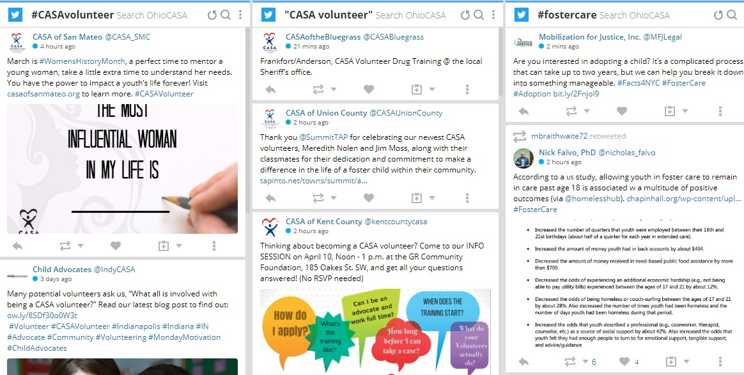

Awareness campaign

  - Interview and develop campaign around authentic messaging

  - Work with Ohio CASA and their Director of Communications for more Awareness campaign ideas

  - Launch April 2023 for Child Abuse Awareness Month

Demographics

Although our social audience is 77% women, with 53% aged 25 – 44 years, we want to ensure our content is not too female- specific, as an important priority is to increase male volunteers.

Paid promotions

$

For all business pages on Facebook (yes, even non profits!) content is automatically deprioritized in the algorithm.

Review policies and reach out to Ohio CASA to determine best practices to promote and increase content availability

Objective #2: E-communication

  - Frequency: Once a month

  - Content: 3 parts | 1) Awareness, 2) Program or volunteer updates, 3) CTA

  - Audience: Volunteers, General mailing list, segmented for specific and additional e-communications

10%
10
12
3

Benchmarks

Increased volunteer base

Speaking engagements per year

Email communications a year (1 per month)

Social media platforms used

2017 data on small non-profits from M+R benchmarks

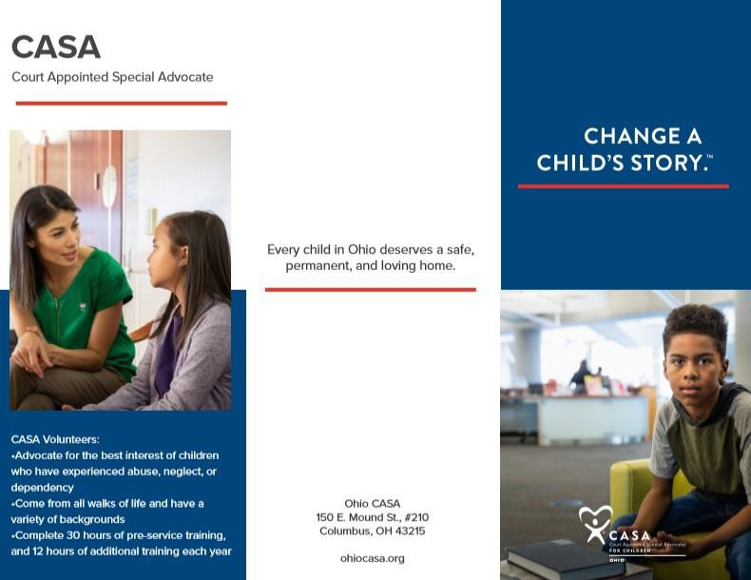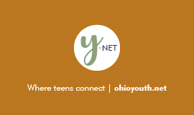

- Distribute CASA brochures and customizable brochures to our local program

- Share Y-Net cards with youth and child welfare professionals to educate more people we serve and work with

- Expand fundraising events and community outreach throughout the counties

