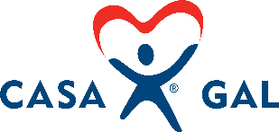

Public Education and
Community Awareness Plan

Goal

To increase awareness, volunteer interest, and digital engagement throughout the county

Annual Benchmarks
10% Increased volunteer base
10 Speaking Engagements
12 email communications (1 per month)
3 social media platforms used

Social Media

- Largest Platform = Highest Reach - Best for news and links - Best for storytelling
- All types of content - PR tool for connecting with media - Younger demographic
- 1 posts per week - 1 post every month - 1 post every 2 weeks

Why Use Social Media?

- Increases an organization’s reach
- Spreads the word about an organization’s mission
- Attracts new donors and keeps existing donors engaged
- Assists in growing a network of volunteers
- Allows audience to participate and feel more engaged

By the Numbers

- 55% of people who engage with organizations on social media end of taking some sort of action
- 59% of those people donate money
- 53% volunteer
- 43% attend or participate in charitable events in their community
- 40% subsequently purchase a product that benefits that charity
- 25% contact their representative by phone, letter, or email after engaging with a cause on social media

CASA/GAL Target Audiences

Already There
- Adults 55-65+, college graduates
- Parents of adult children
- Interests in child development, children’s rights, volunteering, child protection, community, and social services
Age | Facebook | YouTube | Instagram
18-29 | 70% | 95% | 70%
30-49 | 77% | 91% | 48%
50-64 | 73% | 83% | 29%
65+ | 50% | 49% | 13%

On Their Way
- Adults 35-54, college graduates
- Married & parents
- Interests in child development, children’s rights, volunteering, child protection

Ready for the Future
- Adults 18-34, college graduates or some college
- No children
- Likely to engage with political content, activism, cultural diversity, gender equality, social responsibility, volunteering

Preparation for Social Media Campaign

Annually Ask:
- Are the links to our website and social channels correct and working?
- Do we have a donate button on our website? If so, is the donate button linking to the correct place?
- Is our logo correct and visible?
- Are we using consistent profile images across all social media accounts?

Goals, what do we want to achieve:

Time-Based

Relevant

Attainable

Measurable

Specific

What are our resources:
- Tools:
  - What software do we have in place for design, scheduling, and analytics? What do we need? What can we afford?
- Team:
  - How big is our marketing and/or social media team? What are the options for freelance, volunteer, or other support?
- Time:
  - What channels are our priority? How much time can we devote to developing or posting content?

Audience

- Clearly understand who your audience is for this campaign or post
- Tailor message
- Choose channels that audience uses frequently

Appealing to Audience

- Use content and images to inspire
  - Storytelling connects and engages people; share stories of impacted youth
- Focus on outcomes
  - Tell donors how a gift will impact children and youth in community
  - Make the donor or potential volunteer the hero of the story
  - Make it about the mission

Messaging and Content

Messaging | Content
Identify Key messages based on goals and audience | Utilize campaign calendar to manage post timing
Utilize same message over and over again to gain recognition and awareness | Balance fundraising requests with thank you messages
Piggy-back off other awareness campaigns: foster care month, child abuse awareness month, volunteer month, Giving Tuesday, Year-End Fundraisers | Think like the audience
Appeal to potential volunteer’s desire to make a difference | Links to next steps: how to volunteer, how to donate, etc.

Raising Awareness

- Ensure brand consistency
  - Utilize NCASA and Ohio CASA resources for appropriate messaging and photo content
- Use and repeat key messages
- Social listening – monitor content related to our industry and share as appropriate
- Utilize subject matter experts
- Amplify message across channels

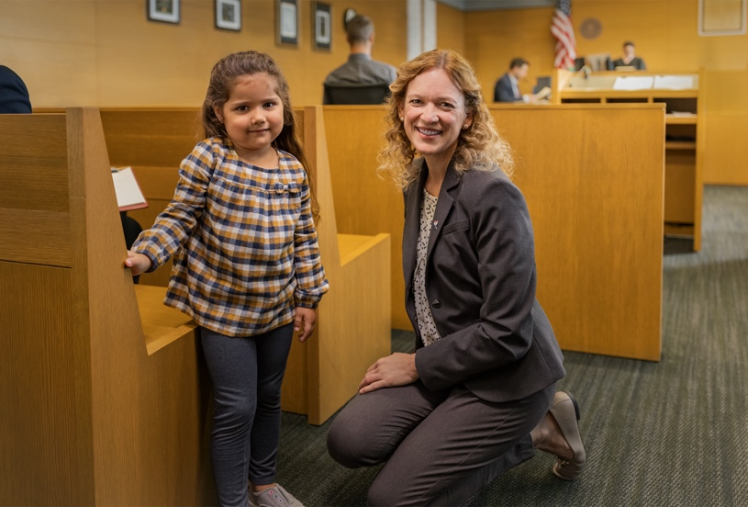
Monthly Guide to Public Education and Community Awareness:

 | Acquisitions | Local Businesses | Corporate Sponsorships | Current Volunteers | Past Volunteers | Grants
January
February | Newspaper Article
March |  |  | Annual Report with Envelope | Quarterly Newsletter with appeal |  | Research Grant Opportunities
April | Social Media Blast – Child Abuse Awareness Month | Child Abuse Awareness Month Flyer |  |  | Direct mailing with Child Abuse Awareness Month appeal
May | National Foster Care Month |  | Direct Contact | Volunteer’s Day Cards –Certificate of Appreciation
June | Reunification Month |  |  | Volunteer Appreciation Event |  | VOCA Grant
July | Social Media blast |  |  |  |  | County Commissioner Appeal
August |  |  |  |  | Thank you postcards
September |  | Newsletter with Envelope |  |  |  | United Way Grant
October | Newspaper Article

Source: National CASA’s Webinar - “How to Develop and Implement a Social Media Campaign for Awareness, Recruitment or Fundraising”
Taken from program’s Resource Development Plan

