CASA of ___________ Diversity, Equity and Inclusion Plan

Policy: CASA of ___________ County is committed to diversity, equity and inclusion. CASA of ___________ strives to have CASA volunteers and members of staff represent not only the ___________ County population, but more importantly, the population that exists within the foster care system with respect to gender, race, ethnicity, sexual orientation, people with disabilities, cultural, geographical, and socioeconomic status. In our multicultural society, we work to be an inclusive program valuing and celebrating the diversity of talents, viewpoints and life experiences of each individual. To achieve this goal, CASA of ___________ County will develop, implement and annually review a Diversity, Equity and Inclusion Plan that outlines the activities necessary to obtain staff and volunteers that reflect the population and needs of the children served.
Data: CASA of ___________ County will annually collect and review data in regards to the county's population. Some key demographics reviewed will be race, ethnicity, nationality, socioeconomic status, gender, sexual orientation and disability status. This data will be compared to the data of those children served by the program and within the foster care system of ___________ county to inform the program on the disproportionalities that exist as well as what efforts the programs need to implement to address said discrepancies.
Training: CASA of ___________ County is committed to training staff, volunteers and other representatives of the program of the disparities and disproportionalities of those served within ___________ County’s foster care system. This will include, at the minimum, addressing diversity, equity and inclusion during the pre-service training as well as one in-service dedicated to diversity training per year.

Goal #1: Community Needs Assessment
Questions to consider:
● What are the demographics of Licking County? Where can this information be found?
● What are the demographics of the children served by the program? And what are the demographics of the overall population of children in care? How is this information compiled?
● What are the demographics of our volunteers? How is this information compiled?
● How do the demographics of CASA’s compare to the demographics of children served? What populations are overrepresented/underrepresented?
Objectives/Action Steps  Specific, measurable activities to achieve goals. | Who Person Responsible | When Timeline | How The way the goal will be measured, data collected/observed
Step 1: Receive data on the potential population of children served/ those in foster care COMPLETED BELOW | Executive Director through Juvenile Court and JFS | Completed at the conclusion of each year, starting Jan. 2021 | By completion
Step 2: Create Data collection volunteer form to give out with volunteer manual | Executive Director | By first training | By completion
Step 3: Compare the demographics at the conclusion of year one to see where recruitment efforts are lacking | Executive Director | By Jan 2022 | Create a presentation outlining the comparison. Who’s overrepresented/underrepresented?

According to the 2019 Census, ___________ County’s population is 45,316 with 93% of this population being white, 2% were black and 2% were of mixed race. Median household income is $56,754 /year. Almost 26% of the population is under the age of 18. According to PCSAO Factbook (2018-2019) the placement rate is 9.5 children in custody per 1,000.
According to PCSAO Factbook (2018-2019) the placement rate is 9.5 children in custody per 1,000. This data states that there were 599 reports screened in related to child abuse or neglect and that 103 children were placed in out of home care in the year 2018. Graphs are shown below according to the demographics of the children in care on 7/1/2018 (PCSAO factbook).
Throughout the United States, LGBTQ+ children are also overrepresented in foster care. Though those who identify as LGBTQ+ make up 11% of the U.S population, they make up 30% of the foster care population. LGBTQ identifying children may enter foster care for the same reasons as non-LGBTQ youth, with the additional layer of trauma that comes with being mistreated because of their sexual orientation, gender identity or gender expression. This disproportionality is compounded with a host of additional disparities whilst in care. Additionally, LGBTQ identifying youth in rural America, like ___________ County, can be expected to experience even more obstacles or mistreatment due to religious assumptions and more traditional values.
Demographics on 7/1/2018 (PCSAO factbook)

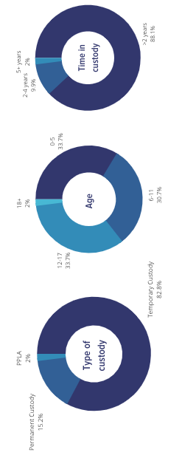

Projected Representation Goals
Projected CASA volunteer based on Gender
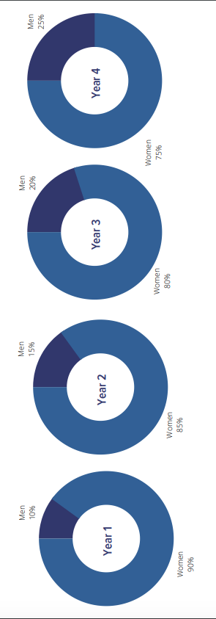
Projected CASA volunteer based on Race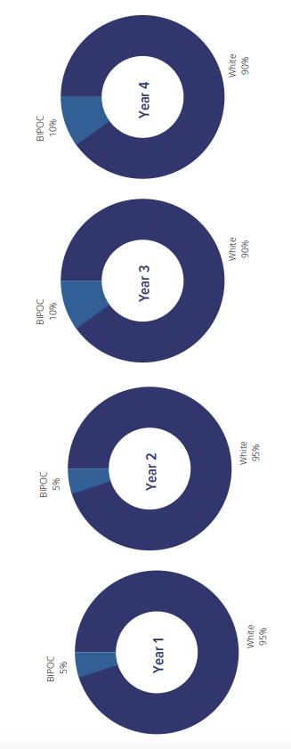
*https://www.pcsao.org/pdf/factbook/2017/___________.pdf

Goal #2: Build collaborative partnerships for sustainable community engagement
Questions to consider:
● Based on research compiled in Goal 1, which demographic groups does CASA of LC want to target?
● Which African American organizations or black owned businesses can we partner with? Which community leaders should we invite into the conversation? Do we have a liaison or ‘ambassador’ we can use to help initiate these conversations?
● Which LGBTQ organizations can we partner with? Which community leaders are missing from the conversation? Do we have a liaison or ‘ambassador’ we can use to help initiate these conversations?
● Which men’s organization (frats, masons, amvets) can we partner with? Which community leaders are missing from the conversation? Do we have a liaison or ‘ambassador’ we can use to help initiate these conversations?
● Who else is missing? Which perspectives are we missing? Who else is lacking in recruitment efforts or who can offer in-service training?

Objectives/Action Steps Specific, measurable activities to achieve goals. | Who Person Responsible | When Timeline | How The way the goal will be measured, data collected/observed
Step 1: Compile a list of black owned business/organizations, predominantly male orgs and LGBT+ orgs. | Executive Director | July 2021 | By completion
Step 2: Create marketing materials specifically for those groups | Executive Director with assistance from OhioCASA | July 2021 | By completion
Step 3: Reach out/present the partnership to the organization | Executive Director | October 2021 | By completion, review of effort

Goal #3: Recruitment and Retention of Diverse Volunteer Advocates
Questions to consider:
- Were the efforts made successful? Who is missing from the table?
- Who do we still need to target? What relationships do we already have that could help?
- What resources can we use?
  - Partnerships, social media, festivals/events, newspaper, etc.

Objectives/Action Steps Specific, measurable activities to achieve goals. | Who Person Responsible | When Timeline | How The way the goal will be measured, data collected/observed
Step 1: Evaluate if efforts so far have been success, look at Program stats | Executive Director | Jan 2022 | By completion
Step 2: Create new efforts, establish targets for following year | Executive Director | Jan 2022 | By completion
Step 3: Reach out/recruit | Executive Director | Jan 2022 | By completion, review of effort

Goal #4: Inclusion and training
Questions to consider:
- Would CASA volunteers or staff benefit from additional cultural competency training that will help the program become more inclusive and affirming?
- Who is missing from the conversation?
- Reflection on CASA of ___________ appearance, if you belonged to one of the following groups, would you feel welcomed and represented in the following platforms?

 | Website | Among Staff, volunteers | Marketing materials | Are there other CASA’s that look like me?
African American
LGBTQ
Male
Socio-economic status
Age

Objectives/Action Steps Specific, measurable activities to achieve goals. | Who Person Responsible | When Timeline | How The way the goal will be measured, data collected/observed
Step 1: Go through above table and check the inclusivity of the program/materials created | Executive Director | Every year starting Jan 2022 | By completion
Step 2: Make edits to materials | Executive Director | Feb 2022 | By completion
Step 3: Schedule culturally competent training, set target for amount of available training and desired audience attendance | Executive Director | Mar 2022 | Measure by responses of attendees in a evaluation before and after training

Scheduling review of this document
This one page document is to be included in the Diversity and Inclusion Plan. The Diversity and Inclusion Plan should be reviewed by the Executive Director annually or as changes need to be made. Below is the scheduling of the next review.
Last Revised: Jan 23rd. 2021
Next Review Scheduled: Jan. 2022
First Adopted: Feb. 2021
Revision History: Created by CASA of ___________ Jan. 23rd 2021

